Year 3 homework 22.10.20
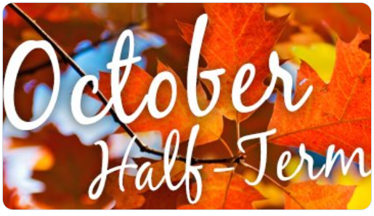
Maths:
Neolithic Numbers
This activity links with the Stone Age theme and provides a practical way of understanding place value.
You will need: natural materials like stones, sticks and conkers.
- Why do we need maths? Would Stone Age people have needed to know about number? What might Stone Age people count?
- These are some different systems to represent a number and explain how they show the number e.g. 24
ՈՈՈIIII (Ancient Egyptian); XXIV (Roman numerals); 11000 (binary system); 二十四(Japanese); 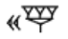(Babylonian); tally marks, etc.
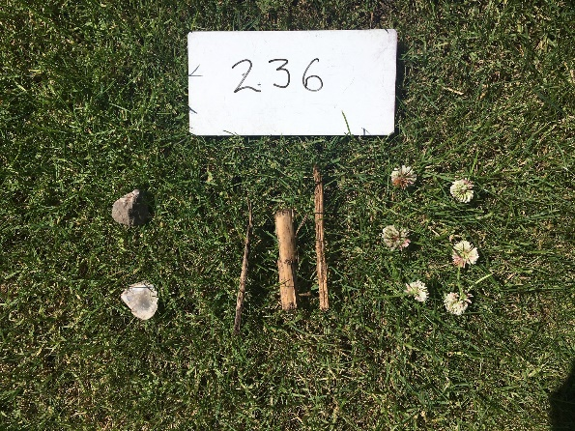
- Find and use natural resources in their outdoor area to create their own number system.
- Share children’s number systems. Can they explain how they work?

English: With your SeeSaw login, logon to SeeSaw and complete the activity.
Writing task- Stone Age prepositions
You can upload your work in whichever way you prefer.

Reading:
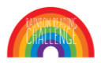
October half-term is a perfect time to curl up with a reading book! Each child has received a new Rainbow Reading Challenge bookmark ready to be stamped once they have read a book at home. Below is a recap of the Rainbow Reading Challenge.
Rainbow Reading Challenge Re-cap
•To encourage children to read for pleasure at home, we are continuing our whole-school reading reward challenge. The reading challenge re-starts each new academic year, with all children starting by earning their red badge in their new year group. Children will receive stamps on bookmark cards based on how many books they have read at home. This does not include their school guided reading book but instead books of choice. We have attached a recommended reading list on the class page for each year group to help with suggestions for high quality texts.
· KS2 children will receive 2 stamps per book or 4 stamps if they choose to read a book from the recommended reading list of books for their new year group (this is discretionary by the teacher for longer books!)
· Bookmark cards will be stamped by your child’s class teacher once an adult at home has confirmed the book has been completed. Just a signature in your child’s reading diary is all that’s needed or alternatively sign the bookmark itself.
•Each time your child fills a bookmark card (see below for how stamps and badges correlate) they will receive a colour badge in our weekly class celebration assembly with the aim of collecting all the colour badges of the rainbow. Once the whole rainbow reader challenge has been achieved for the new academic year, your child’s name will be entered into a raffle for a prize.

10 stamps = red badge 50 stamps = blue badge
20 stamps = orange badge 60 stamps = indigo badge
30 stamps = yellow badge 70 stamps = violet badge
40 stamps = green badge

