Home Learning – Mallard Duck - Week 2
In addition to the activities below, please remember to read every day! You might also like to challenge yourself to learn and practise some of the words from the Year 3 and 4 statutory spellings list.
Keep track of how much you read and we can fill in our rainbow reading book marks when we get back to school.
Day 1
Maths | English | History | Art
Focus on Times tables  https://www.topmarks.co.uk/maths-games/hit-the-button or TTRockstars.  Practise whichever times table you need to focus on.  Use many different methods. Write it down, sing a song from YouTube, play an online game, design a poster, get someone at home to test you.  Today, spend all of your Maths work time doing it.  For every other day this week, practise yours times tables for 10 minutes in addition to the Maths work.  When you’re confident and ready – move on -in this order:  2x, 10x, 5x, 3x, 4x, 8x, 6x, 7x, 9x, 11x ,12x | Complete the fronted adverbial work below, adding a fronted adverbial to each sentence to make them more interesting. | Research what the Ancient Greek people wore.  https://www.ducksters.com/history/ancient_greece/clothing.php  https://www.bbc.co.uk/bitesize/topics/z87tn39  Can you see the differences between what men and women wore and the rich and the poor?  Make notes to help you with your Art which follows this… | Design an Ancient Greek outfit.  Consider who would wear it.  Draw your outfit and label it.
Day 2
Maths | English | Science | PE
Add and subtract 1s, 10s, 100s and 1000s  Watch the lesson (follow the Vimeo link below) then complete the activity worksheet (PDF sent as an attachment with this email).  You can either print the worksheet and write on it or look at it on the screen and write your answers on paper. Just take care to keep your numbers in columns (it’s a bit tricky when you haven’t got a squared Maths book like in school!)  The lesson asks you to pause part way through to complete a few of the questions then continue, but if it’s easier to manage, you can watch the whole lesson, then complete the whole activity.  Lesson: https://vimeo.com/461777711  Activity : Tuesday Maths Activity PDF | Choose one of the mythical creatures from Ancient Greece. You might remember one we have met in school or you can research this before you begin.  Write a description of the creature.  Try to include:  - expanded noun phrases (with two ambitious adjectives separated by a comma)  - a simile or metaphor  - powerful verbs to describe its actions. (How does it move? What sounds does it make?) | Investigate states of matter.  Look at a puddle outside (create your own if it hasn’t been raining!)  Draw around the puddle with chalk.  What happens throughout the day?  Check and describe the changes every half hour.  Can you explain what is happening in scientific language?  Check your understanding of States of Matter at:  https://www.bbc.co.uk/bitesize/topics/zkgg87h | Design a HIIT workout (this is one which will make you out of breath and work your whole body!)  Try your workout with someone in your family.
Day 3
Maths | English | R.E. | Music
Add two 3-digit numbers (not crossing 10 or 100)  Watch the lesson (follow the Vimeo link below) then complete the activity worksheet (PDF sent as an attachment with this email).  You can either print the worksheet and write on it or look at it on the screen and write your answers on paper. Just take care to keep your numbers in columns (it’s a bit tricky when you haven’t got a squared Maths book like in school!)  The lesson asks you to pause part way through to complete a few of the questions then continue, but if it’s easier to manage, you can watch the whole lesson, then complete the whole activity.  Lesson: https://vimeo.com/461778453  Activity: Wednesday Maths Activity PDF  Challenge: Snappy Maths Sheet 1 | Look at the Greek Gods and Goddesses (below) and consider their possessions. What are they wearing and holding? You could even think about the powers they possess.  Write a list of them- using an apostrophe for possession.  For example:  Athena’s spear  Now turn these ideas into sentences  For example:  Many of the other Gods quivered at the sight of Athena’s sharp, shining spear.  If it is a plural, remember to put the apostrophe after the s, for example:  The Gods’ powers were both varied and feared.  What happens if it ends in s, e.g. Zeus?  You can do either Zeus’s thunderbolts or Zeus’ thunderbolts | Light is very important in many religions.  Consider examples of this in different religions then make an information poster to show this. (e.g. diva lamp in Hinduism and the menorah in Judaism) | Did the Ancient Greeks enjoy music?  What instruments might they have used?  http://www.ancientgreecefacts.com/greek-musical-instruments/  http://kotsanas.com/gb/exh.php?exhibit=2102002  Using recycled materials, make your own musical instrument. It could be blown, shaken or plucked.  Treat someone at home to a performance!
Day 4
Maths | English | PSHE | French
Add two 4-digit numbers with no exchange  Watch the lesson (follow the Vimeo link below) then complete the activity worksheet (PDF sent as an attachment with this email).  You can either print the worksheet and write on it or look at it on the screen and write your answers on paper. Just take care to keep your numbers in columns (it’s a bit tricky when you haven’t got a squared Maths book like in school!)  The lesson asks you to pause part way through to complete a few of the questions then continue, but if it’s easier to manage, you can watch the whole lesson, then complete the whole activity.  Lesson: https://vimeo.com/461778690  Activity: Thursday Maths Activity PDF | Make a Top 10 list of your favourite books.  Name the book, the author and then briefly describe why you like it and who you would recommend it to.  For example:  The Twits by Roald Dahl. I like this book because the characters are funny and Roald Dahl uses great description so I can imagine what they are really like. I would recommend it to my uncle because he likes funny books and mischievous behaviour.  We’d love to share these in class so that we’re never stuck for a great book to choose! | Last week you were kind and helpful- now think about who helps you at home.  Make a thank you card or write a thank you letter to someone to make them smile.  Use your best joined handwriting to really impress them! | Draw your family and label them in French.  https://www.bbc.co.uk/bitesize/articles/zgqp7yc  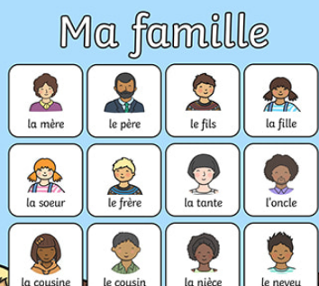

Day 1 English – Fronted Adverbials
Add a fronted adverbial to the beginning of each sentence to give more detail and make it more interesting.
Remember to use fronted adverbials which tell us when, how and where.
Remember to add a comma after the fronted adverbial.

e.g. After many years at war, Odysseus and his men arrived on the island.
They entered the cave.
The Cyclops returned to the cave.
He gobbled up two of the men.
Odysseus sharpened the long wooden stake to a point.
The men thrust it into the Cyclops’s one eye.
The Cyclops fell to the ground.
The men hid under the sheep to escape.
He shouted to Odysseus that his father, Poseidon would seek his revenge.

Challenge: Can you add expanded noun phrases to further improve your sentences?

Fronted adverbials you could use (but I’m sure you can think of better ones yourselves!)
Quickly | After many years at war | Cunningly
Without warning | In an instant | Hearts pounding
Terrified | Bravely | As the sun set/ rose
A few second/hours later | Suddenly | In the darkness
Without a care | Raging with anger | Far away

Day 3 English – Gods and Goddesses
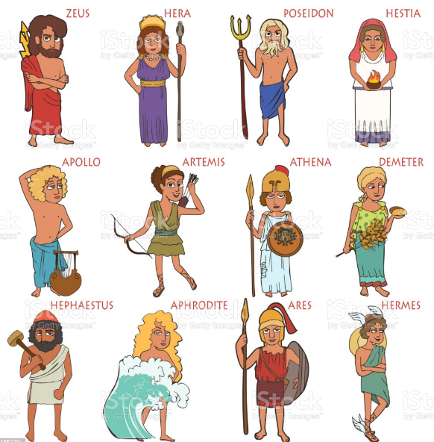

Day 5 English
