Home Learning Format - Week 1
Please send us one email per day attaching all the photos of the work completed for that day.
Day 1
Mathematics | Literacy | Reading | Physical Development
Gather some small objects such as Lego, buttons, pasta, stones etc. Ask your child to count different sets of up to 5 identical objects. Can you count the objects? Can you touch the objects as you count? How many objects are there altogether?  Challenge: Can you match the numeral to the set of objects? | Watch Geraldine the Giraffe ‘s’ to re-cap.  https://www.youtube.com/watch?v=sUmUpf-JNoU  Look at the images below and colour the initial sound that matches the picture.  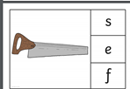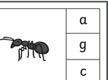  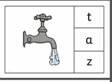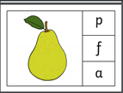  (see larger images below)  Challenge: Draw your own picture and write the initial sound or word. | Listen to the story ‘Owl Babies’.  https://www.youtube.com/watch?v=TPQRiSTYFHo  Why did Bill feel sad? | https://www.cosmickids.com/category/watch/?energy=&changed=energy  Click on the link above and choose an active session to get your bodies warmed up and moving.  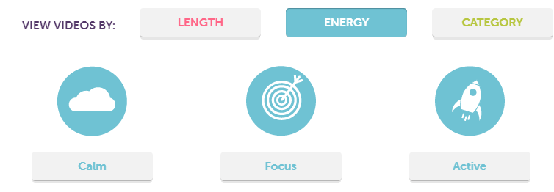
Day 2
Maths | Literacy | Reading | Expressive arts and design
Gather a large group of different objects or colours such as a set of colouring pencils. Ask your child to count out different sets of objects up to 5 from the larger group. Do you know how many pencils there are? Do you know how many without counting? Does it matter that the pencils are different colours?  Challenge: If I have 2 pencils, then there are 3 left in the pot. Am I correct? | Watch Geraldine the Giraffe ‘a’ to re-cap.  https://www.youtube.com/watch?v=KtNWFUVgaRk&t=147s  Read the captions below and draw a picture to show the caption you read.  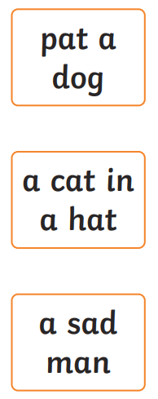(see larger image below) | 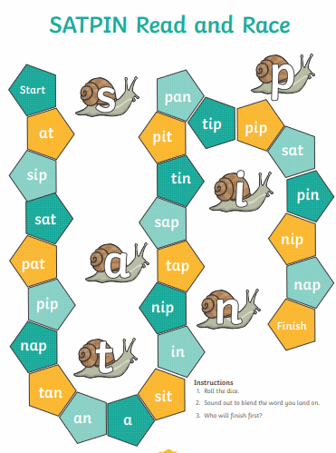  (see larger image below)  Roll the dice and stretch the word you land on to read it. Who will finish the board first? | 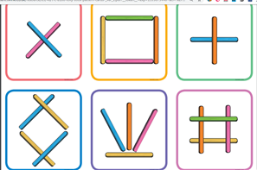  Can you use lolly sticks or straws to re-create these shapes and patterns?
Day 3
Maths | Literacy | Reading | Personal, social and emotional development
Watch numberblocks - three  https://www.bbc.co.uk/iplayer/episode/b08bzgxx/numberblocks-series-1-three  Look at the image and discuss which images show 3. Tick the images that represent 3. Discuss - do the objects have to be in a line? Is there only one way of showing three?  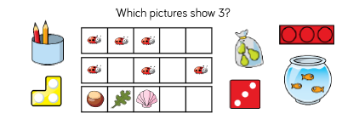  (see larger image below)  Challenge: Can you draw your own picture that represents 3? | Watch Geraldine the Giraffe ‘t’ to re-cap.  https://www.youtube.com/watch?v=EmlzzMTqBxo  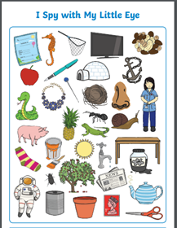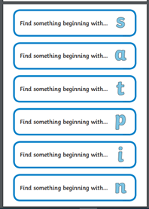  (see larger image)  Circle the objects beginning with the sounds and write the sounds next to the object. | Listen to the story ‘Peace at Last’  https://www.youtube.com/watch?v=9U9y35kWBvM  What were the noises that kept Mr Bear awake? | https://www.youtube.com/watch?v=Ih0iu80u04Y Listen to the story of The colour monster. Then….  Create your own feelings Monster. How do you think they are feeling?  Draw a face on the monster and colour them in.
Day 4
Maths | Literacy | Reading | Understanding of the world
Watch numberblocks - four  https://www.bbc.co.uk/iplayer/episode/b08d61cv/numberblocks-series-1-four  Have four baskets of different items – shells/buttons/pasta/lego. Take four items out of the basket and arrange them on the table. How many are there altogether? Can you make the same as me?  Ask your child to close their eyes and then re-arrange the objects.  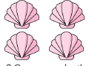  How many are there now? Do you need any more objects from the basket? Did it change the number when I re-arranged them?  Challenge: Can you go outside and find other objects that show me 4?  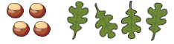 | Listen to the story of Room on the Broom. What rhyming words can you hear?  https://www.youtube.com/watch?v=_uQulEnxsRo  Look at the image (see larger images and more examples below) Say the words for the pictures. Which word does not rhyme and is the odd one out?  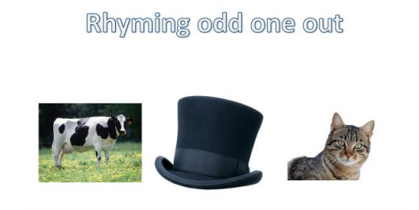  Challenge: Create your own rhyming string. How many more words can you think of that rhyme with hat and cat? | Stretch the words to read them. Draw on the sound buttons to help you stretch them.  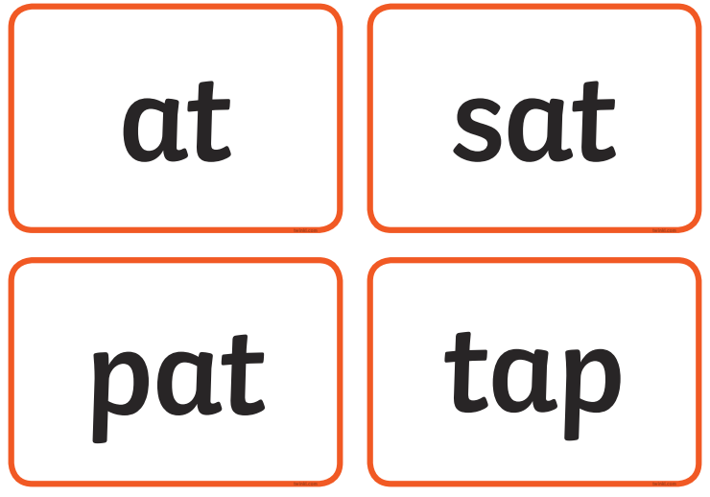 | https://www.bbc.co.uk/teach/class-clips-video/the-changing-seasons/zh4rkmn  Watch the clip. Can you spot the season autumn? What happened to the weather and the leaves and trees?  Can you go on an Autumn hunt and spot any signs of Autumn? Use the checklist below to help you.  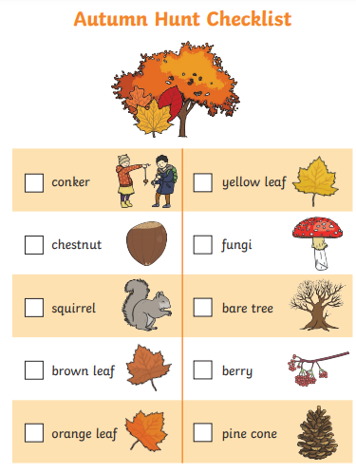
Day 5
Maths | Literacy | Reading | RE
Watch numberblocks - five  https://www.bbc.co.uk/iplayer/episode/b08d630h/numberblocks-series-1-five  Can you count to five on your fingers? Can you count forwards and backwards?  Can you look at my hands and tell me the number without counting? (subitise)  Provide the children with cups,buckets or containers with the numerals 0 – 5 on. Can you collect the correct number of items for each bucket?  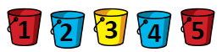  Challenge: Tip out the sets of objects. Can you write the number to show how many objects in each set? | Sing the alphabet song to practise the name and sounds of the letters.  https://www.youtube.com/watch?v=ffeZXPtTGC4  Have a tray of salt, flour, sugar, sand or glitter and practise forming the lowercase letters of the alphabet.  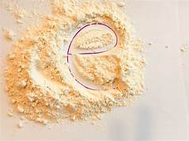  Challenge: Can you practise writing the letters in your name? | Listen to the story ‘Zog’  https://www.youtube.com/watch?v=9_LmS3q4E6k  Which words in the story rhyme? | Listen to the story of ‘Guess how much I love you’.  https://www.youtube.com/watch?v=LPLwMxogYDU  Our Christian value for this half term at Overleigh is love. Use the template below or draw your own and put inside the people or objects you love? Think about why you love them.

Home Learning Format - Week 2
Please send us one email per day attaching all the photos of the work completed for that day.
Day 1
Maths | Literacy | Reading | Physical Development
Practise counting backwards from 5 by singing the song below.  https://www.youtube.com/watch?v=-mi79hRcSXI  Have a look at the image below. Can you match the dot images to the correct numeral. Numbers 3,4,5 have 2 dot images each. Does it matter that the dots are different colours and in a different pattern?  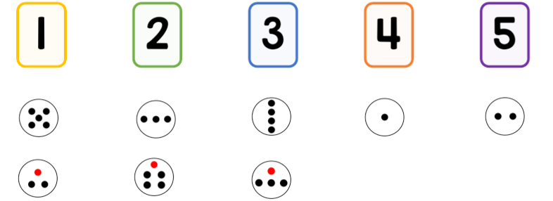  (see larger image below)  Challenge: Can you draw your own dot pattern to represent one of the numbers. | Watch Geraldine the Giraffe ‘p’ to re-cap.  https://www.youtube.com/watch?v=q0akp_j1nbc  Look at the images below and colour the initial sound that matches the picture.  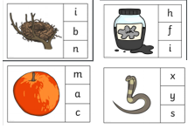  (see larger image)  Challenge: Draw your own picture and write the initial sound or word. | 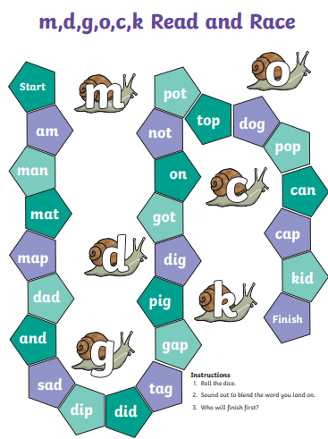  (see larger image below)  Roll the dice and stretch the word you land on to read it. Who will finish the board first? | https://www.dailymotion.com/video/x5xivrz  Click on the link and follow the instructions to learn the dinosaur dance.
Day 2
Maths | Literacy | Reading | Expressive arts and design
Look at the image. What is the same and what is different about the two sets of children in the picture? Could you sort the children differently?  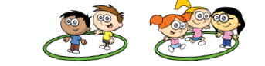  Provide a range of real objects such as leaves, shells, toy vehicles, Lego, pebbles.  Can you sort your objects into groups? How can you sort them? Think about colour, shape, size etc.  Challenge: Can you sort the same objects in a different way? | Watch Geraldine the Giraffe ‘i’ to re-cap.  https://www.youtube.com/watch?v=0gi8OBhl11U  Read the caption and match them to the picture.  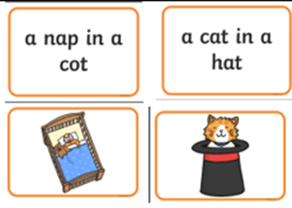 | Watch the story of the ‘Gruffalo’  https://youtu.be/s8sUPpPc8Ws  What ingredients do you think might go in a Gruffalo crumble? | Autumn Tree Handprint  Paint your hand and beginning of your arm in brown paint and print to make the trunk and branches of the tree. Use your fingers to print leaves onto the tree. Think about the colours of the leaves during autumn. What happens if some of the colours mix together?  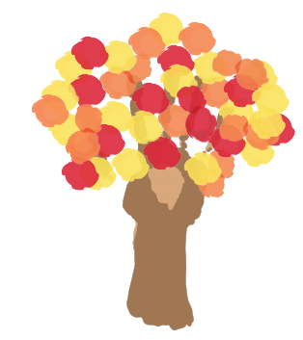
Day 3
Maths | Literacy | Reading | Personal, social and emotional development
Watch the story The Button Box and discuss the different types of buttons as the story is read. How are they the same and different?  https://www.youtube.com/watch?v=APY-JJ_6TPs  Play Guess my Rule. Using the images below. Discuss how the buttons have been sorted. Can you guess my rule for sorting them?  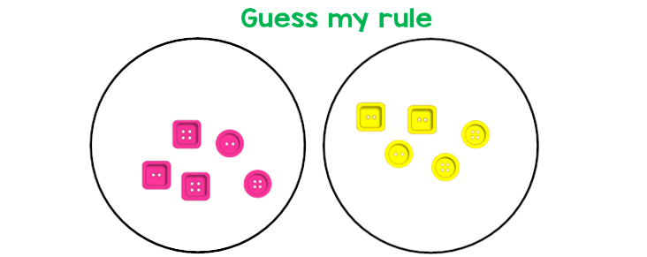  (see more and larger images below)  Challenge: Can you sort your own buttons and ask a grown up to guess your rule? | Watch Geraldine the Giraffe ‘n’ to re-cap.  https://www.youtube.com/watch?v=IQsCAyq-axU  Write the sounds below on card or paper and match them to the correct picture.  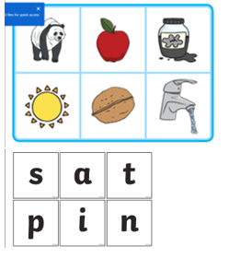  (see larger image below) | Stretch the words to read them. Draw on the sound buttons to help you stretch them.  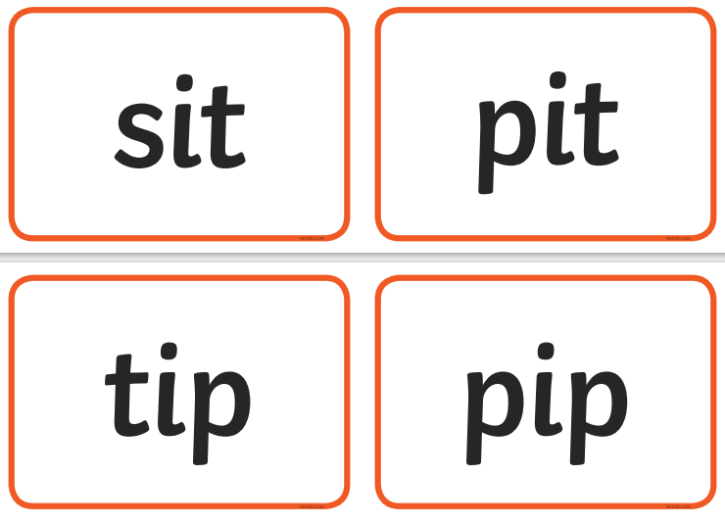 | Re-watch the story of the colour monster. https://www.youtube.com/watch?v=Ih0iu80u04Y  When he is yellow, he is feeling happy.  What makes you feel happy? Draw a picture to show us.  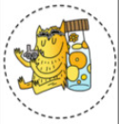
Day 4
Maths | Literacy | Reading | Understanding of the world
Practise counting to 5 with this song.  https://www.youtube.com/watch?v=de0Beo16fqI  Look at the sets of objects. Which is the odd one out? Can you explain why?  Challenge: Can you make your own set of objects, with an odd one out. | Sing the alphabet song to practise the name and sounds of the letters.  https://www.youtube.com/watch?v=ffeZXPtTGC4  With a set of plastic/wooden letters, or letters written on cards, arrange the letters in alphabetical order. Take it in turns to take away one of the letters – can you/your child spot which letter is missing? Take it in turns to put one letter in the wrong place. Can the other spot it and put it back in the right place?  Challenge: Practise saying the letter names as well as the letter sounds. | Listen to the story ‘Aliens love underpants’.  https://youtu.be/s8sUPpPc8Ws  Can you spot the rhyming words? | Re-watch the clip showing Autumn. What is the weather like in Autumn?  https://www.bbc.co.uk/teach/class-clips-video/the-changing-seasons/zh4rkmn  Ted needs to get dressed and isn’t sure what to wear in Autumn. Can you draw a picture of some of the clothes he will need to help him?  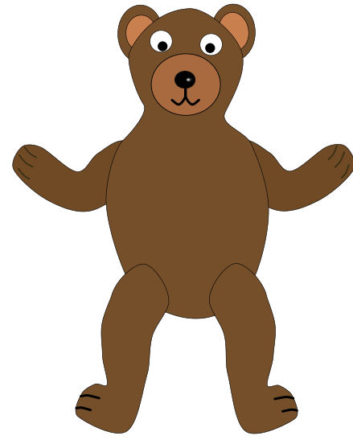
Day 5
Maths | Literacy | Reading | RE
Sorting numbers  Look at the collection of numerals, dot patterns, numicon and fingers. Ask the children how the pictures can be sorted.  (The children may group by quantity, all dot patterns together, sets of 3 and not sets of 3.)  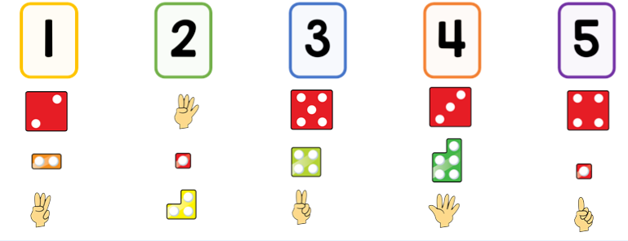 | Watch Geraldine the Giraffe ‘m’ to re-cap.  https://www.youtube.com/watch?v=Xh6Ux5D2D84  Use a dry wipe pen to write letters on building blocks, Duplo or Lego. Can you build some words using the letters (s,a,t,p,I,n,m,d)  e.g.sat/pin/dad/man/map/nip/pat/  tin/tap/ | Read the words by stretching them and find the matching picture.  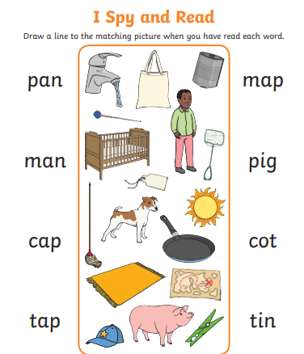 | Watch the parable of the Lost sheep.  God loves everyone and wants everyone to be his friend.  https://www.youtube.com/watch?v=094upaf4BME  Make a sheep following the instructions below. Hide your sheep somewhere in your house. Draw a map so that someone in your family can find your sheep.

