Mallard Duck - Home Learning - Week 1
In addition to the activities below, please remember to read every day!
Keep track of how much you read and we can fill in our rainbow reading book marks when we get back to school.
Day 1
Maths | English | History | Art
In Year 4, you are expected to be able to read the time on an analogue clock and also change between digital and analogue times.  Today, draw around a round object and make yourself an analogue clock. Where do the numbers go? What number go next to each other. Can you find a relationship between the opposite number?  On the outside of the circle, next to each number, mark how many minutes past or to the hour this position can also mean.  Watch the video and complete the activities on:  https://www.bbc.co.uk/bitesize/topics/zkfycdm/articles/zcrmqty | In English, we have been enjoying different Greek myths. This week’s work will all be based on another Greek myth – Pandora’s Box.  Watch the video of the story of Pandora’s Box.  https://www.bing.com/videos/search?q=greek+myth+pandoras+box&adlt=strict&view=detail&mid=3EBAC28F10D7B42D454A3EBAC28F10D7B42D454A&&FORM=VRDGAR&ru=%2Fvideos%2Fsearch%3Fq%3Dgreek%2520myth%2520pandoras%2520box%26qs%3Dn%26form%3DQBVR%26sp%3D-1%26ghc%3D1%26pq%3Dgreek%2520myth%2520pandoras%2520box%26sc%3D3-23%26sk%3D%26cvid%3D3C74C30044804466A42EA8695379B4C5  List which features of a myth it has.  We have been learning these for the last few weeks in English. Hint: Is it set long ago? Does it have Gods? Is there a problem? Is the ending tragic?  Retell the story on a comic strip.  Next, try to use your comic strip to tell this myth to someone in your family. Use expression to keep their attention. | Research Art and Culture in Ancient Greek times.  https://www.bbc.co.uk/bitesize/topics/z87tn39/articles/zgpdjxs  https://www.dkfindout.com/uk/history/ancient-greece/ancient-greek-art/  https://www.ducksters.com/history/art/ancient_greek_art.php  Explore Ancient Greek buildings, floors or fabric to find patterns that represent elements of Greek life.  Can you find any familiar characters, Gods/Goddesses or parts of stories you have heard over the last few weeks? | Apply your knowledge of Ancient Greek patterns.  - Try to copy some of the designs and create your own repeated pattern design.  - Design your own Greek pot or vase. Choose one of the shapes below and consider what it would be used for? Add your patterns and designs.
Day 2
Maths | English | Science | PE
On a piece of card (look in your recycling if you don’t have any), draw a larger clock like the one you did yesterday. Make a longer minute hand and a shorter hour hand and if you can, attach them to the centre of the clock so that they can move round – I have used a drawing pin stuck into a rubber to do this in the past).  Now show an adult the times for o’clock, then explain the times on the half past the hour and then the quarters. Finally, talk to an adult about the other divisions on the clock and what they mean. The poster below the grid could help you with this.  Today, try to look at the clock as often as possible and make a timetable of what time you complete things,  e.g.  7.30 – Get up  8.10 – Have breakfast… | Imagine you are Pandora.  Write your diary for the day when you opened the box.  In a diary, you retell events which have happened and describe your thoughts and feelings.  Remember:  - write in past tense  - write in first person (‘I…’)  - use descriptive language  - describe your thoughts and feelings.  Challenge yourself:  Last week, we focused on using fronted adverbials. Can you include any in your diary recount? | Changes in the seasons  The weather has become very unpredictable in the last couple of weeks.  Predict what you expect to see changing in nature as it changes to Autumn. Look at the sky, the trees and plants and animals.  Research and explain why these changes are happening.  You could draw a picture and describe what is happening. | Try a Joe Wicks – The Body Coach workout.  Which is your favourite move? Can you teach someone at home?
Day 3
Maths | English | R.E. | Music
Solve the time Reasoning questions below the grid using A.P.E. to answer, prove explain.  Use the clock that you made to help you.  (Ignore the numbers of each question!) | 1.Draw (just a quick sketch) what you imagine Pandora’s box to look like, then label it using expanded noun phrases. Try to use two adjectives separated by a comma.  Consider its shape, material, openings, locks, special features or patterns.  2.Write a paragraph to describe the box. You could start with the opening.  Pandora gazed in wonder at the box. It was …  Try to include:  - expanded noun phrases  - ambitious, exciting adjectives  - a simile | Think of something you are grateful for.  Write a prayer to say thank you.  Decorate it beautifully! | Ask a family member who their favourite musical artist/ singer or band is. Listen to one of their tracks.  What is your opinion and why? Can you describe the music in 5 words?
Day 4
Maths | English | PSHE | French
Money – revision from last year  Have a look around your house and find as many different types of British coins as possible.  Make a poster explaining the value of each coin. Also, include the relationships between them for example – how many 20ps are in £1?  Challenge: How many different ways can you make £2.50? Draw the alternative methods. | Read the poem ‘The Magic Box’ by Kit Wright (see below).  What do you like about it?  What do you dislike?  Do you have any questions you’d like to ask?  Use a dictionary (paper or online version) to look up any unknown words.  Choose your five favourite lines and draw a picture to illustrate each line. | We have been thinking about love this half term. Being helpful and kind to someone is one way to show that you love them.  Make a list of some things you could do to help someone else in your house.  How many can you tick off this week? | Revise the numbers 1-20 in French.  Can you teach someone at home or record your voice?  There are lots of fun songs on YouTube to help you to practise!
Day 5
Maths | English | Science | Computing
Look at the questions below. Use the work that you did yesterday to help you solve the problems – it really helps to have the physical coins in front of you if possible. | Write your own version of ‘The Magic Box’.  Use the same structure as the poem, so each verse have the line:  I will put in the box  Followed by three lines describing what would go into the box.  Be imaginative and creative!  We are really excited to share these poems. | Archimedes was a famous Greek scientist. He discovered that placing an object in a container full of water displaced the water. You could look online to discover more about his theory.  https://www.bbc.co.uk/teach/class-clips-video/science-ks2-discovering-the-work-of-archimedes/z6gj382  Try out Archimedes’ theory by playing in the (not too full!) bath or a (not too full!) washing up bowl.  What happens?  Photograph, draw or write a description of your findings. | Choose a game to play to practise your times tables.  You could choose TTRockstars, Hit the Button or a different game.

Week 1 Day 3 Time reasoning questions:
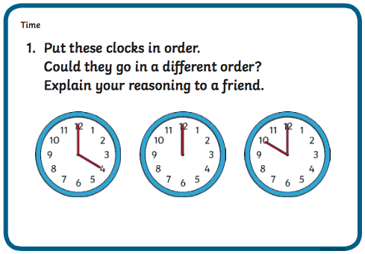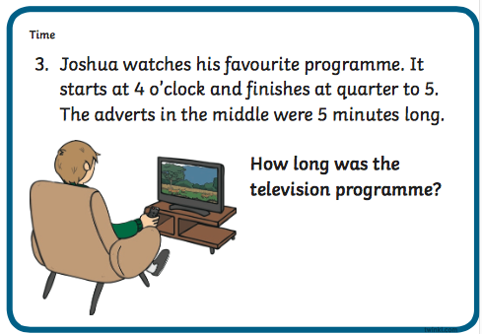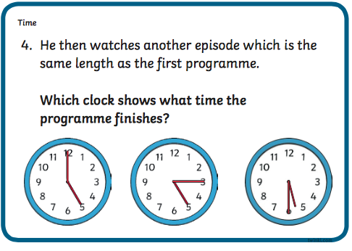
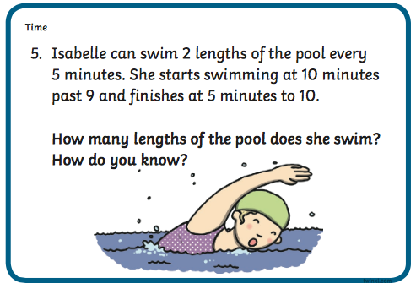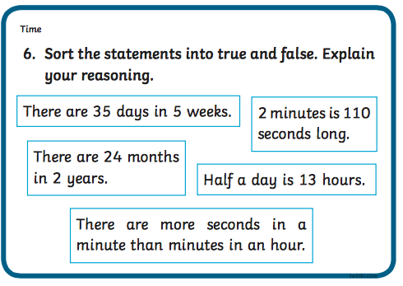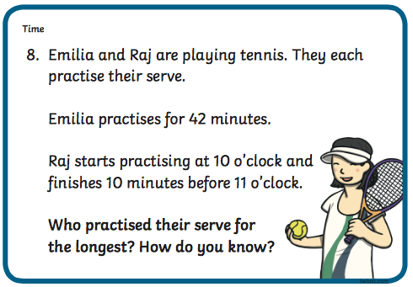
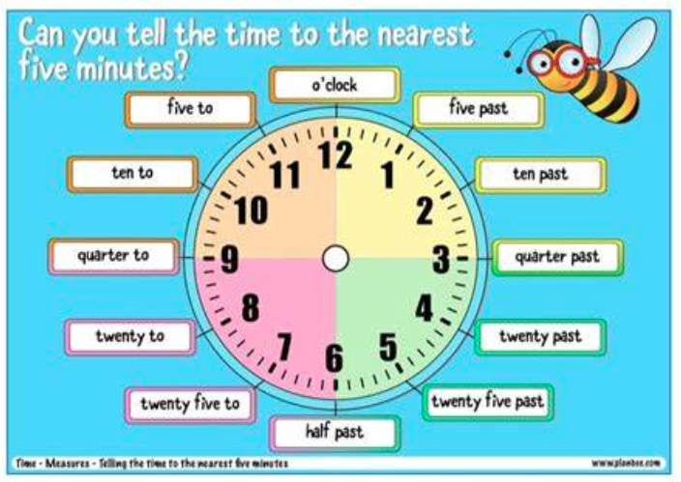

Week 1 Day 5 maths:
